**CHAPTER 3**

**Classi€cation**



With Early Release ebooks, you get books in their earliest form— the author’s raw and unedited content as he or she writes—so you can take advantage of these technologies long before the official release of these titles. The following will be Chapter 3 in the final release of the book.



In Chapter 1 we mentioned that the most common supervised learning tasks are regression (predicting values) and classification (predicting classes). In Chapter 2 we explored a regression task, predicting housing values, using various algorithms such as Linear Regression, Decision Trees, and Random Forests (which will be explained in further detail in later chapters). Now we will turn our attention to classification systems.

**MNIST**

In this chapter, we will be using the MNIST dataset, which is a set of 70,000 small images of digits handwritten by high school students and employees of the US Cen‐ sus Bureau. Each image is labeled with the digit it represents. This set has been stud‐ ied so much that it is often called the “Hello World” of Machine Learning: whenever people come up with a new classification algorithm, they are curious to see how it will perform on MNIST. Whenever someone learns Machine Learning, sooner or later they tackle MNIST.

Scikit-Learn provides many helper functions to download popular datasets. MNIST is one of them. The following code fetches the MNIST dataset:1



1 By default Scikit-Learn caches downloaded datasets in a directory called *$HOME/scikit_learn_data*.



**87**

* **from sklearn.datasets import** fetch_openml
* mnist = fetch_openml('mnist_784', version=1)
* mnist.keys()

dict_keys(['data', 'target', 'feature_names', 'DESCR', 'details', 'categories', 'url'])

Datasets loaded by Scikit-Learn generally have a similar dictionary structure includ‐ ing:

* A DESCR key describing the dataset
* A data key containing an array with one row per instance and one column per feature
* A target key containing an array with the labels

Let’s look at these arrays:

* X, y = mnist["data"], mnist["target"]
* X.shape

(70000, 784)

**>>>** y.shape(70000,)

There are 70,000 images, and each image has 784 features. This is because each image is 28×28 pixels, and each feature simply represents one pixel’s intensity, from 0 (white) to 255 (black). Let’s take a peek at one digit from the dataset. All you need to do is grab an instance’s feature vector, reshape it to a 28×28 array, and display it using Matplotlib’s imshow() function:

**import matplotlib as mpl import matplotlib.pyplot as plt**

some_digit = X[0]

some_digit_image = some_digit.reshape(28, 28)

plt.imshow(some_digit_image, cmap = mpl.cm.binary, interpolation="nearest") plt.axis("off")

plt.show()

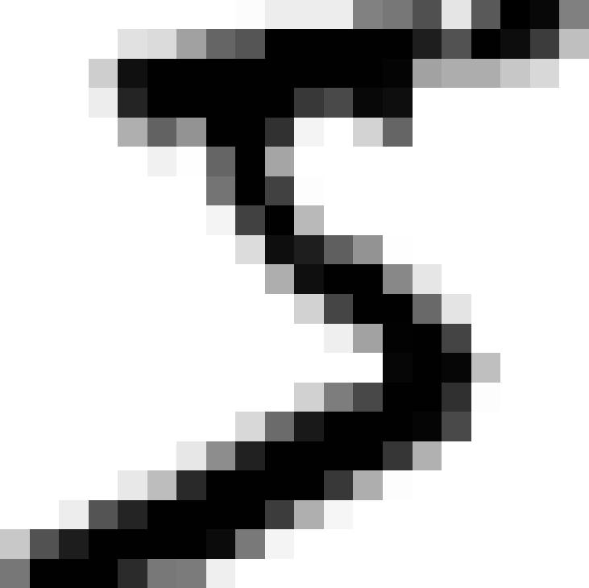

This looks like a 5, and indeed that’s what the label tells us:



**88** **|** **Chapter 3: Classi€cation**

**>>>** y[0]'5'

Note that the label is a string. We prefer numbers, so let’s cast y to integers:

**>>>** y=y.astype(np.uint8)

Figure 3-1 shows a few more images from the MNIST dataset to give you a feel for the complexity of the classification task.

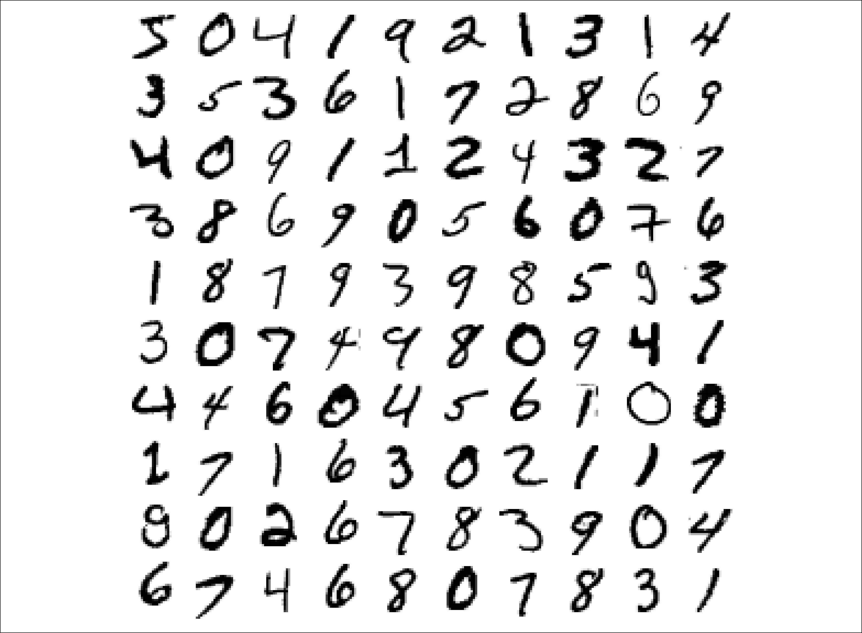

*Figure 3-1. A few digits from the MNIST dataset*

But wait! You should always create a test set and set it aside before inspecting the data closely. The MNIST dataset is actually already split into a training set (the first 60,000 images) and a test set (the last 10,000 images):

X_train, X_test, y_train, y_test = X[:60000], X[60000:], y[:60000], y[60000:]

The training set is already shuffled for us, which is good as this guarantees that all cross-validation folds will be similar (you don’t want one fold to be missing some dig‐ its). Moreover, some learning algorithms are sensitive to the order of the training



**MNIST** **|** **89**

instances, and they perform poorly if they get many similar instances in a row. Shuf‐ fling the dataset ensures that this won’t happen.2

**Training a Binary Classi€er**

Let’s simplify the problem for now and only try to identify one digit—for example, the number 5. This “5-detector” will be an example of a *binary classifier*, capable of distinguishing between just two classes, 5 and not-5. Let’s create the target vectors for this classification task:

y_train_5 = (y_train == 5) *# True for all 5s, False for all other digits.* y_test_5 = (y_test == 5)

Okay, now let’s pick a classifier and train it. A good place to start is with a *Stochastic* *Gradient Descent* (SGD) classifier, using Scikit-Learn’sSGDClassifierclass. This clas‐sifier has the advantage of being capable of handling very large datasets efficiently. This is in part because SGD deals with training instances independently, one at a time (which also makes SGD well suited for *online learning*), as we will see later. Let’s create an SGDClassifier and train it on the whole training set:

**from sklearn.linear_model import** SGDClassifier

sgd_clf = SGDClassifier(random_state=42) sgd_clf.fit(X_train, y_train_5)



The SGDClassifier relies on randomness during training (hence the name “stochastic”). If you want reproducible results, you should set the random_state parameter.

Now you can use it to detect images of the number 5:

**>>>** sgd_clf.predict([some_digit])array([ True])

The classifier guesses that this image represents a 5 (True). Looks like it guessed right in this particular case! Now, let’s evaluate this model’s performance.

**Performance Measures**

Evaluating a classifier is often significantly trickier than evaluating a regressor, so we will spend a large part of this chapter on this topic. There are many performance



1. Shuffling may be a bad idea in some contexts—for example, if you are working on time series data (such as stock market prices or weather conditions). We will explore this in the next chapters.



**90** **|** **Chapter 3: Classi€cation**

measures available, so grab another coffee and get ready to learn many new concepts and acronyms!

**Measuring Accuracy Using Cross-Validation**

A good way to evaluate a model is to use cross-validation, just as you did in Chap‐ ter 2.

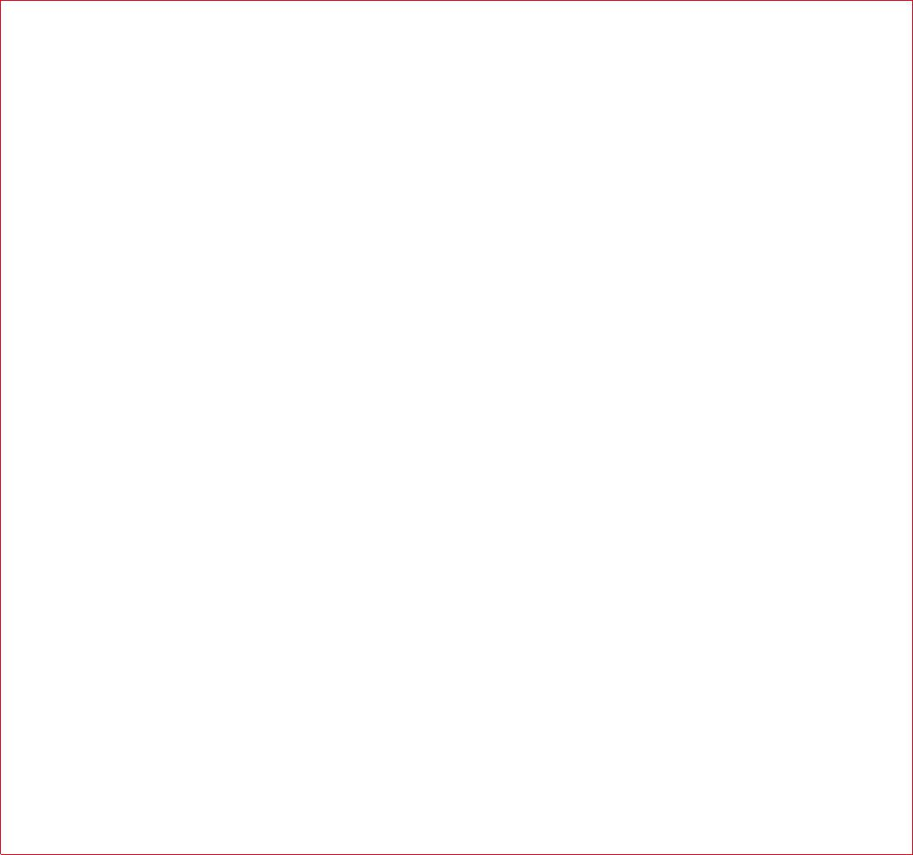

**Implementing Cross-Validation**

Occasionally you will need more control over the cross-validation process than what Scikit-Learn provides off-the-shelf. In these cases, you can implement cross-validation yourself; it is actually fairly straightforward. The following code does roughly the same thing as Scikit-Learn’s cross_val_score() function, and prints the same result:

**from sklearn.model_selection import** StratifiedKFold **from sklearn.base import** clone

skfolds = StratifiedKFold(n_splits=3, random_state=42)

**for** train_index, test_index **in** skfolds.split(X_train, y_train_5): clone_clf = clone(sgd_clf)

X_train_folds = X_train[train_index] y_train_folds = y_train_5[train_index] X_test_fold = X_train[test_index] y_test_fold = y_train_5[test_index]

clone_clf.fit(X_train_folds, y_train_folds) y_pred = clone_clf.predict(X_test_fold) n_correct = sum(y_pred == y_test_fold)

**print**(n_correct/len(y_pred)) *# prints 0.9502, 0.96565 and 0.96495*

The StratifiedKFold class performs stratified sampling (as explained in Chapter 2) to produce folds that contain a representative ratio of each class. At each iteration the code creates a clone of the classifier, trains that clone on the training folds, and makes predictions on the test fold. Then it counts the number of correct predictions and outputs the ratio of correct predictions.

Let’s use the cross_val_score() function to evaluate your SGDClassifier model using K-fold cross-validation, with three folds. Remember that K-fold cross-validation means splitting the training set into K-folds (in this case, three), then mak‐ ing predictions and evaluating them on each fold using a model trained on the remaining folds (see Chapter 2):



**Performance Measures** **|** **91**

* **from sklearn.model_selection import** cross_val_score
* cross_val_score(sgd_clf, X_train, y_train_5, cv=3, scoring="accuracy") array([0.96355, 0.93795, 0.95615])

Wow! Above 93% *accuracy* (ratio of correct predictions) on all cross-validation folds? This looks amazing, doesn’t it? Well, before you get too excited, let’s look at a very dumb classifier that just classifies every single image in the “not-5” class:

**from sklearn.base import** BaseEstimator

**class Never5Classifier**(BaseEstimator): **def** fit(self,X,y=None):

**pass**

**def** predict(self,X):

**return** np.zeros((len(X),1),dtype=bool)

Can you guess this model’s accuracy? Let’s find out:

* never_5_clf = Never5Classifier()
* cross_val_score(never_5_clf, X_train, y_train_5, cv=3, scoring="accuracy") array([0.91125, 0.90855, 0.90915])

That’s right, it has over 90% accuracy! This is simply because only about 10% of the images are 5s, so if you always guess that an image is *not* a 5, you will be right about 90% of the time. Beats Nostradamus.

This demonstrates why accuracy is generally not the preferred performance measure for classifiers, especially when you are dealing with *skewed datasets* (i.e., when some classes are much more frequent than others).

**Confusion Matrix**

A much better way to evaluate the performance of a classifier is to look at the *confu‐* *sion matrix*. The general idea is to count the number of times instances of class A areclassified as class B. For example, to know the number of times the classifier confused images of 5s with 3s, you would look in the 5th row and 3rd column of the confusion matrix.

To compute the confusion matrix, you first need to have a set of predictions, so they can be compared to the actual targets. You could make predictions on the test set, but let’s keep it untouched for now (remember that you want to use the test set only at the very end of your project, once you have a classifier that you are ready to launch). Instead, you can use the cross_val_predict() function:

**from sklearn.model_selection import** cross_val_predict

y_train_pred = cross_val_predict(sgd_clf, X_train, y_train_5, cv=3)

Just like the cross_val_score() function, cross_val_predict() performs K-fold cross-validation, but instead of returning the evaluation scores, it returns the predic‐



**92** **|** **Chapter 3: Classi€cation**

tions made on each test fold. This means that you get a clean prediction for each instance in the training set (“clean” meaning that the prediction is made by a model that never saw the data during training).

Now you are ready to get the confusion matrix using the confusion_matrix() func‐ tion. Just pass it the target classes (y_train_5) and the predicted classes (y_train_pred):

* **from sklearn.metrics import** confusion_matrix
* confusion_matrix(y_train_5, y_train_pred) array([[53057, 1522],

[ 1325, 4096]])

Each row in a confusion matrix represents an *actual class*, while each column repre‐ sents a *predicted class*. The first row of this matrix considers non-5 images (the *nega‐* *tive class*): 53,057 of them were correctly classified as non-5s (they are called *true negatives*), while the remaining 1,522 were wrongly classified as 5s (*false positives*).The second row considers the images of 5s (the *positive class*): 1,325 were wrongly classified as non-5s (*false negatives*), while the remaining 4,096 were correctly classi‐ fied as 5s (*true positives*). A perfect classifier would have only true positives and true negatives, so its confusion matrix would have nonzero values only on its main diago‐ nal (top left to bottom right):

* y_train_perfect_predictions = y_train_5 *# pretend we reached perfection*
* confusion_matrix(y_train_5, y_train_perfect_predictions)

|  |  |  |
| --- | --- | --- |
| array([[54579, | | 0], |
| [ | 0, | 5421]]) |

The confusion matrix gives you a lot of information, but sometimes you may prefer a more concise metric. An interesting one to look at is the accuracy of the positive pre‐ dictions; this is called the *precision* of the classifier (Equation 3-1).

*Equation 3-1. Precision*

precision = *TPTPFP*

+

TP is the number of true positives, and FP is the number of false positives.

A trivial way to have perfect precision is to make one single positive prediction and ensure it is correct (precision = 1/1 = 100%). This would not be very useful since the classifier would ignore all but one positive instance. So precision is typically used along with another metric named *recall*, also called *sensitivity* or *true positive rate*



**Performance Measures** **|** **93**

(*TPR*): this is the ratio of positive instances that are correctly detected by the classifier (Equation 3-2).

*Equation 3-2. Recall*

recall = *TPTPFN*

+

FN is of course the number of false negatives.

If you are confused about the confusion matrix, Figure 3-2 may help.

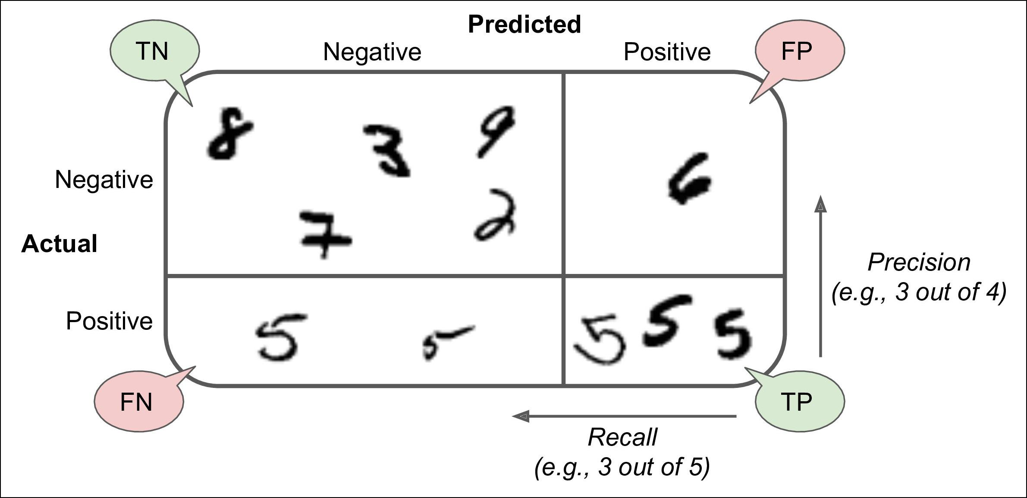

*Figure 3-2. An illustrated confusion matrix*

**Precision and Recall**

Scikit-Learn provides several functions to compute classifier metrics, including preci‐ sion and recall:

* **from sklearn.metrics import** precision_score,recall_score
* precision_score(y_train_5, y_train_pred) *# == 4096 / (4096 + 1522)* 0.7290850836596654
* recall_score(y_train_5, y_train_pred) *# == 4096 / (4096 + 1325)* 0.7555801512636044

Now your 5-detector does not look as shiny as it did when you looked at its accuracy. When it claims an image represents a 5, it is correct only 72.9% of the time. More‐ over, it only detects 75.6% of the 5s.

It is often convenient to combine precision and recall into a single metric called the *F1* *score*, in particular if you need a simple way to compare two classifiers. The F1score isthe *harmonic mean* of precision and recall (Equation 3-3). Whereas the regular mean



**94** **|** **Chapter 3: Classi€cation**

treats all values equally, the harmonic mean gives much more weight to low values. As a result, the classifier will only get a high F1 score if both recall and precision are high.

*Equation 3-3. F1*

|  |  |  |  |  |  |  |  |  |  |  |  |  |
| --- | --- | --- | --- | --- | --- | --- | --- | --- | --- | --- | --- | --- |
| *F*1= | 2 | | |  |  |  | = 2 × | precision × recall | = |  | *TP* |  |
|  |  |  |  |  |  | precision + recall |  |  |  |
| 1 | |  | 1 | |  | *TP* + | *FN* + *FP* |  |
|  |  |  |  | + |  |  |  |  |  | 2 |  |
|  |  | precision | recall |  |  |  |

To compute the F1 score, simply call the f1_score() function:

* **from sklearn.metrics import** f1_score
* f1_score(y_train_5, y_train_pred) 0.7420962043663375

The F1 score favors classifiers that have similar precision and recall. This is not always what you want: in some contexts you mostly care about precision, and in other con‐ texts you really care about recall. For example, if you trained a classifier to detect vid‐ eos that are safe for kids, you would probably prefer a classifier that rejects many good videos (low recall) but keeps only safe ones (high precision), rather than a clas‐ sifier that has a much higher recall but lets a few really bad videos show up in your product (in such cases, you may even want to add a human pipeline to check the clas‐ sifier’s video selection). On the other hand, suppose you train a classifier to detect shoplifters on surveillance images: it is probably fine if your classifier has only 30% precision as long as it has 99% recall (sure, the security guards will get a few false alerts, but almost all shoplifters will get caught).

Unfortunately, you can’t have it both ways: increasing precision reduces recall, and vice versa. This is called the *precision/recall tradeo‰*.

**Precision/Recall Tradeoff**

To understand this tradeoff, let’s look at how the SGDClassifier makes its classifica‐ tion decisions. For each instance, it computes a score based on a *decision function*, and if that score is greater than a threshold, it assigns the instance to the positive class, or else it assigns it to the negative class. Figure 3-3 shows a few digits positioned from the lowest score on the left to the highest score on the right. Suppose the *deci‐* *sion threshold* is positioned at the central arrow (between the two 5s): you will find 4true positives (actual 5s) on the right of that threshold, and one false positive (actually a 6). Therefore, with that threshold, the precision is 80% (4 out of 5). But out of 6 actual 5s, the classifier only detects 4, so the recall is 67% (4 out of 6). Now if you raise the threshold (move it to the arrow on the right), the false positive (the 6) becomes a true negative, thereby increasing precision (up to 100% in this case), but one true positive becomes a false negative, decreasing recall down to 50%. Conversely, lowering the threshold increases recall and reduces precision.



**Performance Measures** **|** **95**

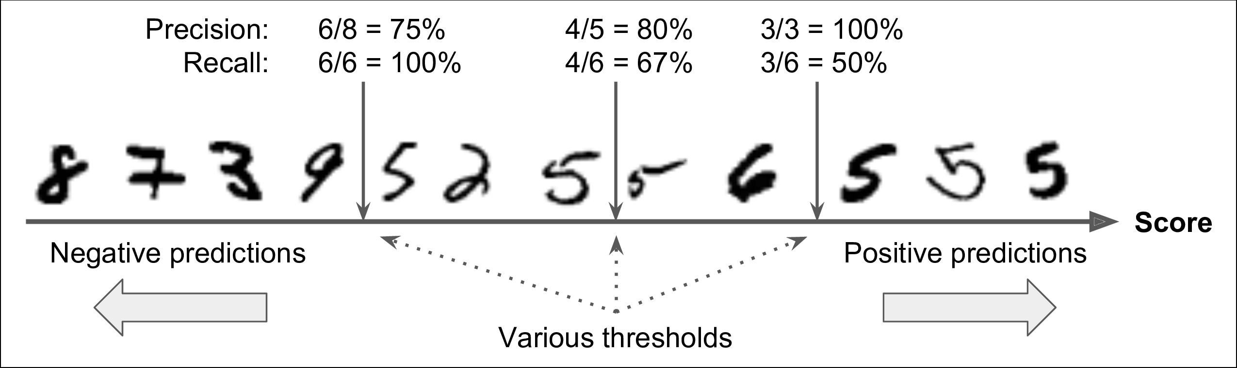

*Figure 3-3. Decision threshold and precision/recall tradeo‰*

Scikit-Learn does not let you set the threshold directly, but it does give you access to the decision scores that it uses to make predictions. Instead of calling the classifier’s predict() method, you can call its decision_function() method, which returns a score for each instance, and then make predictions based on those scores using any threshold you want:

* y_scores = sgd_clf.decision_function([some_digit])
* y_scores

array([2412.53175101])

* threshold = 0
* y_some_digit_pred = (y_scores > threshold) array([ True])

The SGDClassifier uses a threshold equal to 0, so the previous code returns the same result as the predict() method (i.e., True). Let’s raise the threshold:

* threshold = 8000
* y_some_digit_pred = (y_scores > threshold)
* y_some_digit_pred

array([False])

This confirms that raising the threshold decreases recall. The image actually repre‐ sents a 5, and the classifier detects it when the threshold is 0, but it misses it when the threshold is increased to 8,000.

Now how do you decide which threshold to use? For this you will first need to get the scores of all instances in the training set using the cross_val_predict() function again, but this time specifying that you want it to return decision scores instead of predictions:

y_scores = cross_val_predict(sgd_clf, X_train, y_train_5, cv=3, method="decision_function")

Now with these scores you can compute precision and recall for all possible thresh‐ olds using the precision_recall_curve() function:



**96** **|** **Chapter 3: Classi€cation**

**from sklearn.metrics import** precision_recall_curve

precisions, recalls, thresholds = precision_recall_curve(y_train_5, y_scores)

Finally, you can plot precision and recall as functions of the threshold value using Matplotlib (Figure 3-4):

**def** plot_precision_recall_vs_threshold(precisions, recalls, thresholds): plt.plot(thresholds, precisions[:-1], "b--", label="Precision") plt.plot(thresholds, recalls[:-1], "g-", label="Recall")

[...] *# highlight the threshold, add the legend, axis label and grid*

plot_precision_recall_vs_threshold(precisions, recalls, thresholds) plt.show()

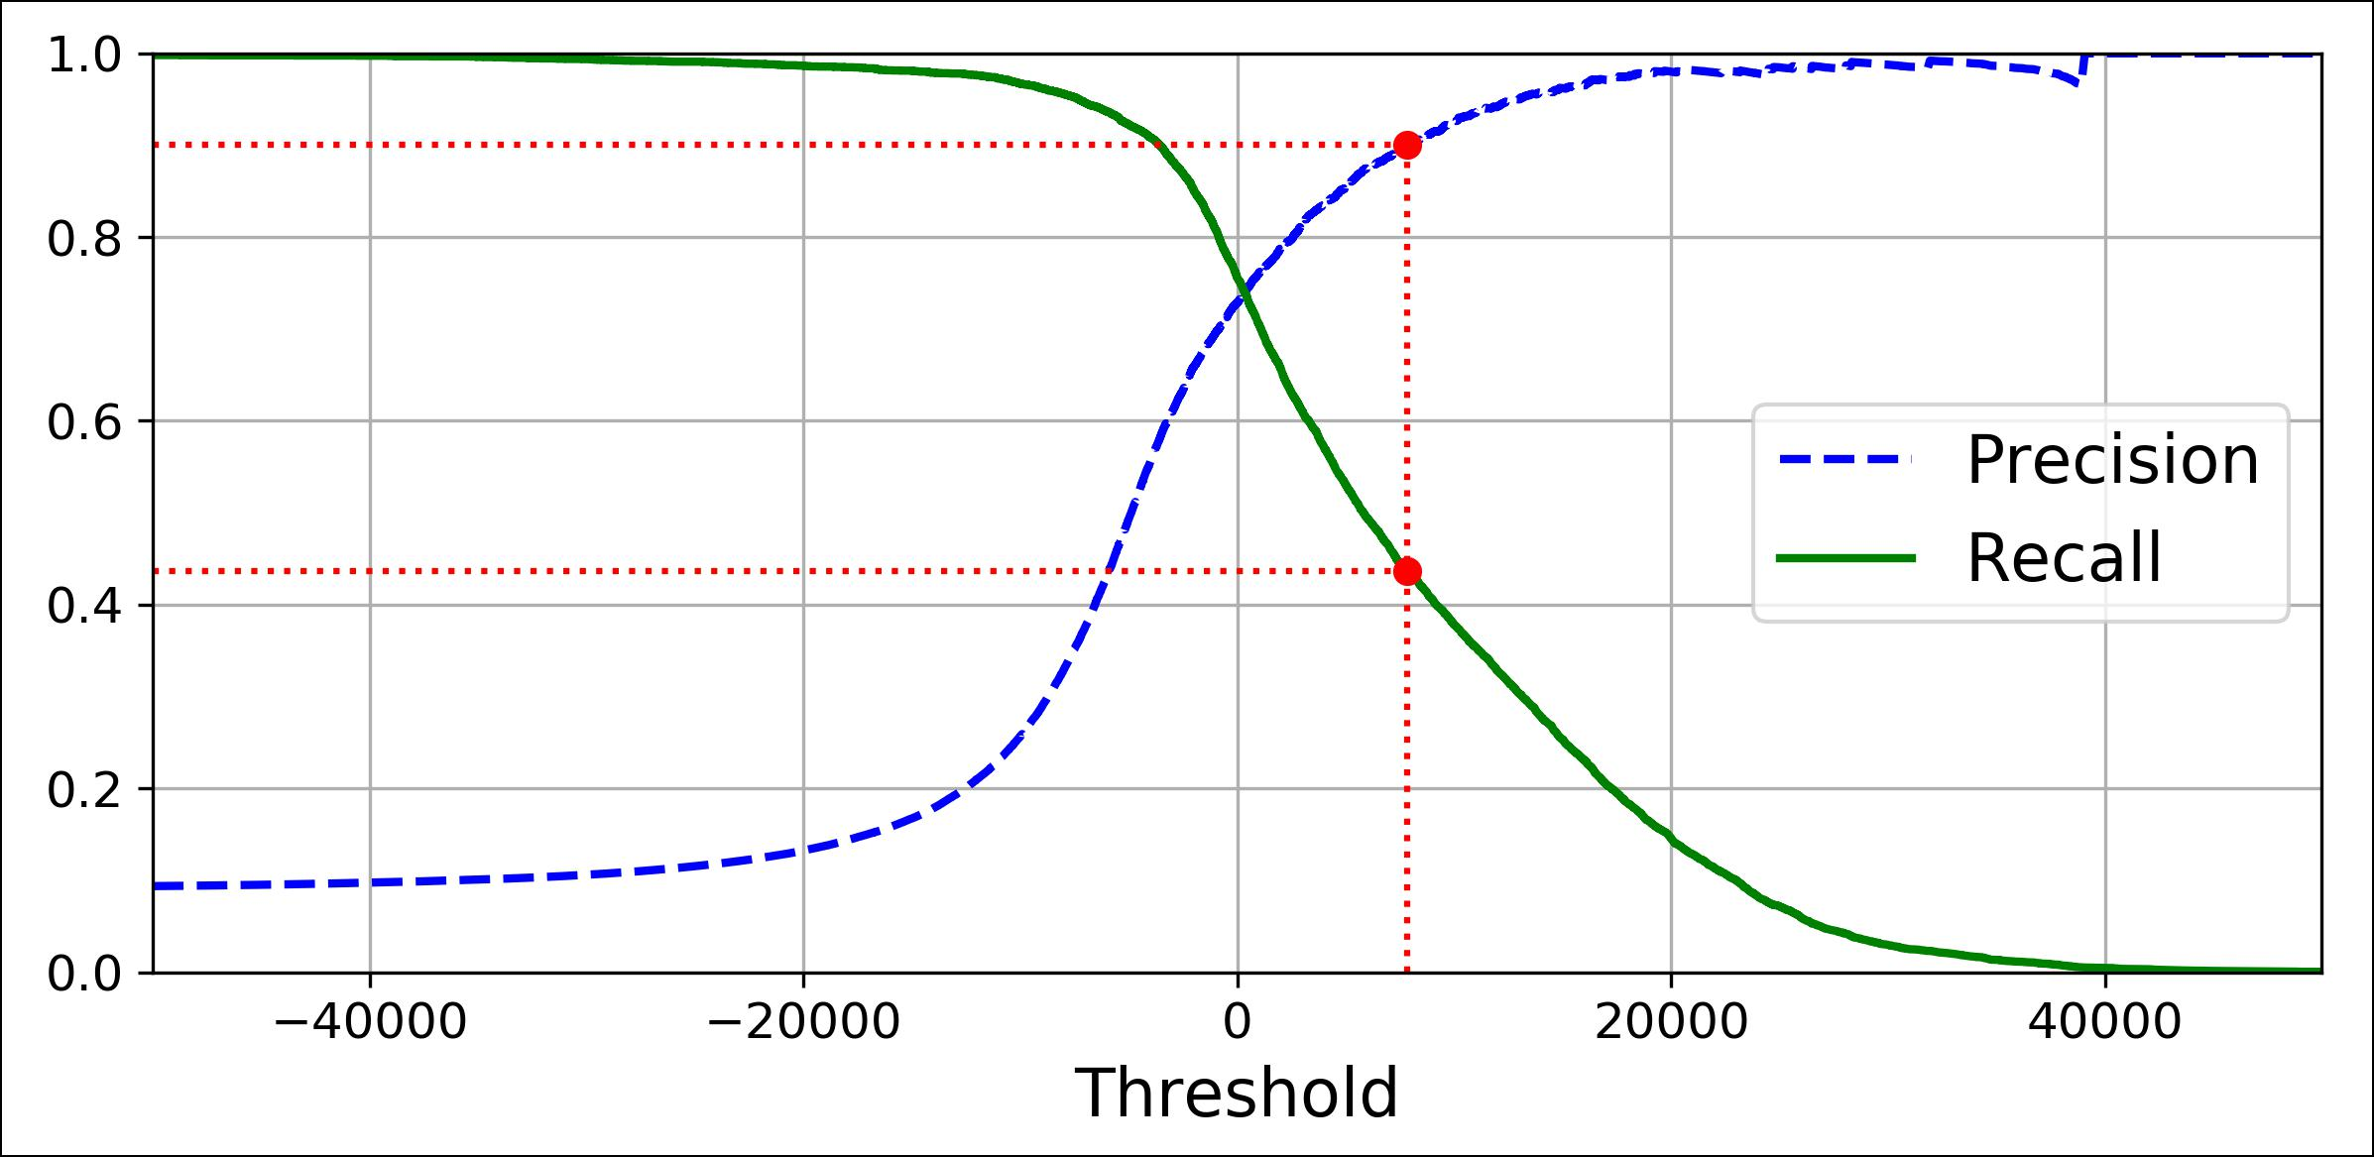

*Figure 3-4. Precision and recall versus the decision threshold*

You may wonder why the precision curve is bumpier than the recall curve in Figure 3-4. The reason is that precision may sometimes go down when you raise the threshold (although in general it will go up). To understand why, look back at Figure 3-3 and notice what happens when you start from the central threshold and move it just one digit to the right: precision goes from 4/5 (80%) down to 3/4 (75%). On the other hand, recall can only go down when the thres‐ hold is increased, which explains why its curve looks smooth.



Another way to select a good precision/recall tradeoff is to plot precision directly against recall, as shown in Figure 3-5 (the same threshold as earlier is highlighed).



**Performance Measures** **|** **97**

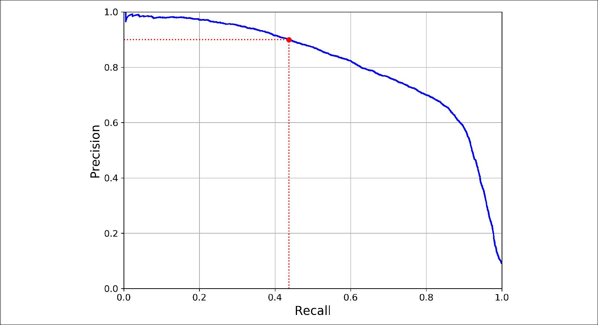

*Figure 3-5. Precision versus recall*

You can see that precision really starts to fall sharply around 80% recall. You will probably want to select a precision/recall tradeoff just before that drop—for example, at around 60% recall. But of course the choice depends on your project.

So let’s suppose you decide to aim for 90% precision. You look up the first plot and find that you need to use a threshold of about 8,000. To be more precise you can search for the lowest threshold that gives you at least 90% precision (np.argmax() will give us the first index of the maximum value, which in this case means the first True value):

threshold_90_precision = thresholds[np.argmax(precisions >= 0.90)] *# ~7816*

To make predictions (on the training set for now), instead of calling the classifier’s predict() method, you can just run this code:

y_train_pred_90 = (y_scores >= threshold_90_precision)

Let’s check these predictions’ precision and recall:

* precision_score(y_train_5, y_train_pred_90) 0.9000380083618396
* recall_score(y_train_5, y_train_pred_90) 0.4368197749492714

Great, you have a 90% precision classifier ! As you can see, it is fairly easy to create a classifier with virtually any precision you want: just set a high enough threshold, and you’re done. Hmm, not so fast. A high-precision classifier is not very useful if its recall is too low!



**98** **|** **Chapter 3: Classi€cation**

If someone says “let’s reach 99% precision,” you should ask, “at what recall?”

**The ROC Curve**

The *receiver operating characteristic* (ROC) curve is another common tool used with binary classifiers. It is very similar to the precision/recall curve, but instead of plot‐ ting precision versus recall, the ROC curve plots the *true positive rate* (another name for recall) against the *false positive rate*. The FPR is the ratio of negative instances that are incorrectly classified as positive. It is equal to one minus the *true negative rate*, which is the ratio of negative instances that are correctly classified as negative. The TNR is also called *specificity*. Hence the ROC curve plots *sensitivity* (recall) versus 1 – *specificity*.

To plot the ROC curve, you first need to compute the TPR and FPR for various thres‐ hold values, using the roc_curve() function:

**from sklearn.metrics import** roc_curve

fpr, tpr, thresholds = roc_curve(y_train_5, y_scores)

Then you can plot the FPR against the TPR using Matplotlib. This code produces the plot in Figure 3-6:

**def** plot_roc_curve(fpr, tpr, label=None): plt.plot(fpr, tpr, linewidth=2, label=label) plt.plot([0, 1], [0, 1], 'k--') *# dashed diagonal*

[...] *# Add axis labels and grid*

plot_roc_curve(fpr, tpr) plt.show()



**Performance Measures** **|** **99**

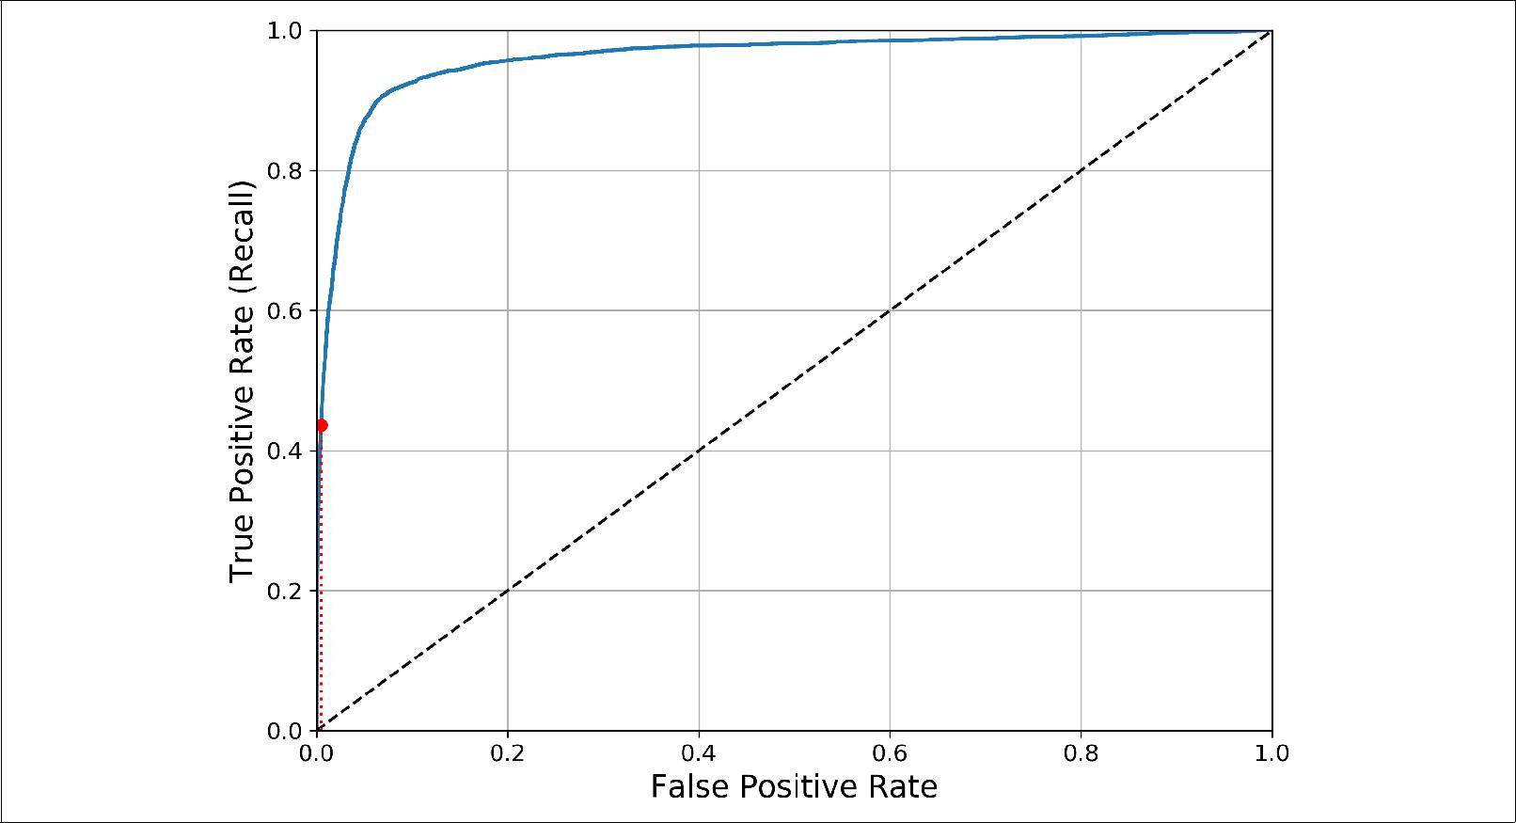

*Figure 3-6. ROC curve*

Once again there is a tradeoff: the higher the recall (TPR), the more false positives (FPR) the classifier produces. The dotted line represents the ROC curve of a purely random classifier; a good classifier stays as far away from that line as possible (toward the top-left corner).

One way to compare classifiers is to measure the *area under the curve* (AUC). A per‐ fect classifier will have a *ROC AUC* equal to 1, whereas a purely random classifier will have a ROC AUC equal to 0.5. Scikit-Learn provides a function to compute the ROC AUC:

* **from sklearn.metrics import** roc_auc_score
* roc_auc_score(y_train_5, y_scores) 0.9611778893101814



Since the ROC curve is so similar to the precision/recall (or PR) curve, you may wonder how to decide which one to use. As a rule of thumb, you should prefer the PR curve whenever the positive class is rare or when you care more about the false positives than the false negatives, and the ROC curve otherwise. For example, looking at the previous ROC curve (and the ROC AUC score), you may think that the classifier is really good. But this is mostly because there are few positives (5s) compared to the negatives (non-5s). In contrast, the PR curve makes it clear that the classifier has room for improvement (the curve could be closer to the top-right corner).



**100** **|** **Chapter 3: Classi€cation**

Let’s train a RandomForestClassifier and compare its ROC curve and ROC AUC score to the SGDClassifier. First, you need to get scores for each instance in the training set. But due to the way it works (see Chapter 7), the RandomForestClassi fier class does not have a decision_function() method. Instead it has a pre dict_proba() method. Scikit-Learn classifiers generally have one or the other. The predict_proba() method returns an array containing a row per instance and a col‐ umn per class, each containing the probability that the given instance belongs to the given class (e.g., 70% chance that the image represents a 5):

**from sklearn.ensemble import** RandomForestClassifier

forest_clf = RandomForestClassifier(random_state=42)

y_probas_forest = cross_val_predict(forest_clf, X_train, y_train_5, cv=3, method="predict_proba")

But to plot a ROC curve, you need scores, not probabilities. A simple solution is to use the positive class’s probability as the score:

|  |  |  |
| --- | --- | --- |
| y_scores_forest = y_probas_forest[:, 1] | *#* | *score = proba of positive class* |
| fpr_forest, tpr_forest, thresholds_forest | = | roc_curve(y_train_5,y_scores_forest) |

Now you are ready to plot the ROC curve. It is useful to plot the first ROC curve as well to see how they compare (Figure 3-7):

plt.plot(fpr, tpr, "b:", label="SGD") plot_roc_curve(fpr_forest, tpr_forest, "Random Forest") plt.legend(loc="lower right")

plt.show()

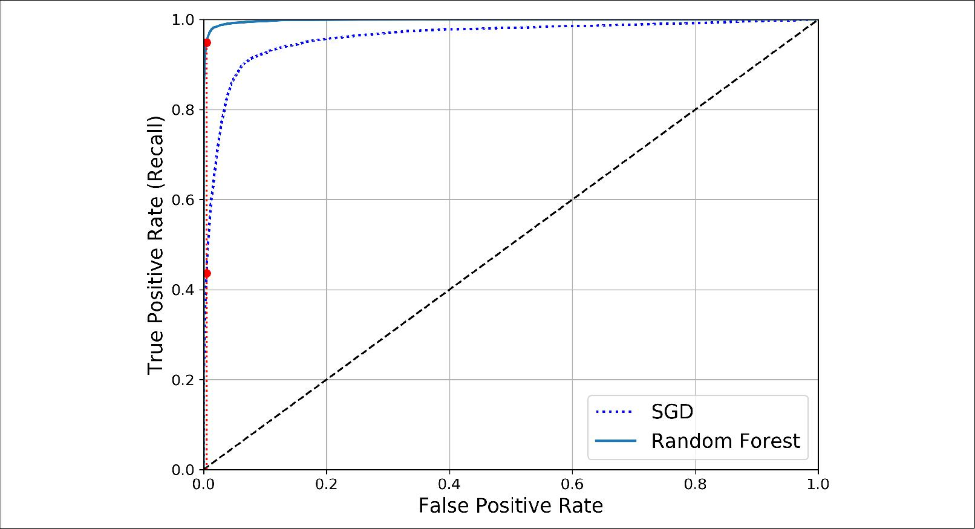

*Figure 3-7. Comparing ROC curves*



**Performance Measures** **|** **101**

As you can see in Figure 3-7, the RandomForestClassifier’s ROC curve looks much better than the SGDClassifier’s: it comes much closer to the top-left corner. As a result, its ROC AUC score is also significantly better:

**>>>** roc_auc_score(y_train_5,y_scores_forest)0.9983436731328145

Try measuring the precision and recall scores: you should find 99.0% precision and 86.6% recall. Not too bad!

Hopefully you now know how to train binary classifiers, choose the appropriate met‐ ric for your task, evaluate your classifiers using cross-validation, select the precision/ recall tradeoff that fits your needs, and compare various models using ROC curves and ROC AUC scores. Now let’s try to detect more than just the 5s.

**Multiclass Classi€cation**

Whereas binary classifiers distinguish between two classes, *multiclass classifiers* (also called *multinomial classifiers*) can distinguish between more than two classes.

Some algorithms (such as Random Forest classifiers or naive Bayes classifiers) are capable of handling multiple classes directly. Others (such as Support Vector Machine classifiers or Linear classifiers) are strictly binary classifiers. However, there are vari‐ ous strategies that you can use to perform multiclass classification using multiple binary classifiers.

For example, one way to create a system that can classify the digit images into 10 classes (from 0 to 9) is to train 10 binary classifiers, one for each digit (a 0-detector, a 1-detector, a 2-detector, and so on). Then when you want to classify an image, you get the decision score from each classifier for that image and you select the class whose classifier outputs the highest score. This is called the *one-versus-all* (OvA) strategy (also called *one-versus-the-rest*).

Another strategy is to train a binary classifier for every pair of digits: one to distin‐ guish 0s and 1s, another to distinguish 0s and 2s, another for 1s and 2s, and so on. This is called the *one-versus-one* (OvO) strategy. If there are *N* classes, you need to train *N* × (*N* – 1) / 2 classifiers. For the MNIST problem, this means training 45 binary classifiers! When you want to classify an image, you have to run the image through all 45 classifiers and see which class wins the most duels. The main advan‐ tage of OvO is that each classifier only needs to be trained on the part of the training set for the two classes that it must distinguish.

Some algorithms (such as Support Vector Machine classifiers) scale poorly with the size of the training set, so for these algorithms OvO is preferred since it is faster to train many classifiers on small training sets than training few classifiers on large training sets. For most binary classification algorithms, however, OvA is preferred.



**102** **|** **Chapter 3: Classi€cation**

Scikit-Learn detects when you try to use a binary classification algorithm for a multi‐ class classification task, and it automatically runs OvA (except for SVM classifiers for which it uses OvO). Let’s try this with the SGDClassifier:

* sgd_clf.fit(X_train, y_train) *# y_train, not y_train_5*
* sgd_clf.predict([some_digit])

array([5], dtype=uint8)

That was easy! This code trains the SGDClassifier on the training set using the origi‐ nal target classes from 0 to 9 (y_train), instead of the 5-versus-all target classes (y_train_5). Then it makes a prediction (a correct one in this case). Under the hood, Scikit-Learn actually trained 10 binary classifiers, got their decision scores for the image, and selected the class with the highest score.

To see that this is indeed the case, you can call the decision_function() method. Instead of returning just one score per instance, it now returns 10 scores, one per class:

* some_digit_scores = sgd_clf.decision_function([some_digit])
* some_digit_scores

array([[-15955.22627845, -38080.96296175, -13326.66694897, 573.52692379, -17680.6846644 , 2412.53175101, -25526.86498156, -12290.15704709, -7946.05205023,

-10631.35888549]])

The highest score is indeed the one corresponding to class 5:

* np.argmax(some_digit_scores)

5

* sgd_clf.classes_

array([0, 1, 2, 3, 4, 5, 6, 7, 8, 9], dtype=uint8)

**>>>** sgd_clf.classes_[5]5

When a classifier is trained, it stores the list of target classes in its classes_ attribute, ordered by value. In this case, the index of each class in the classes_ array conveniently matches the class itself (e.g., the class at index 5 happens to be class 5), but in general you won’t be so lucky.

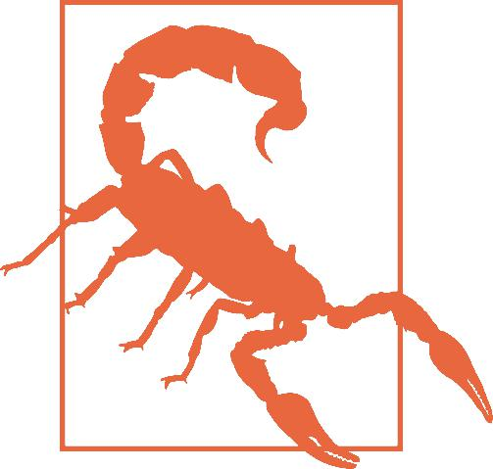

If you want to force ScikitLearn to use one-versus-one or one-versus-all, you can use the OneVsOneClassifier or OneVsRestClassifier classes. Simply create an instance and pass a binary classifier to its constructor. For example, this code creates a multi‐ class classifier using the OvO strategy, based on a SGDClassifier:

* **from sklearn.multiclass import** OneVsOneClassifier
* ovo_clf = OneVsOneClassifier(SGDClassifier(random_state=42))
* ovo_clf.fit(X_train, y_train)
* ovo_clf.predict([some_digit])



**Multiclass Classi€cation** **|** **103**

array([5], dtype=uint8)

**>>>** len(ovo_clf.estimators_)45

Training a RandomForestClassifier is just as easy:

* forest_clf.fit(X_train, y_train)
* forest_clf.predict([some_digit]) array([5], dtype=uint8)

This time Scikit-Learn did not have to run OvA or OvO because Random Forest classifiers can directly classify instances into multiple classes. You can call predict_proba() to get the list of probabilities that the classifier assigned to each instance for each class:

**>>>** forest_clf.predict_proba([some_digit])

array([[0. , 0. , 0.01, 0.08, 0. , 0.9 , 0. , 0. , 0. , 0.01]])

You can see that the classifier is fairly confident about its prediction: the 0.9 at the 5th index in the array means that the model estimates a 90% probability that the image represents a 5. It also thinks that the image could instead be a 2, a 3 or a 9, respec‐ tively with 1%, 8% and 1% probability.

Now of course you want to evaluate these classifiers. As usual, you want to use cross-validation. Let’s evaluate the SGDClassifier’s accuracy using the cross_val_score() function:

**>>>** cross_val_score(sgd_clf,X_train,y_train,cv=3,scoring="accuracy")array([0.8489802 , 0.87129356, 0.86988048])

It gets over 84% on all test folds. If you used a random classifier, you would get 10% accuracy, so this is not such a bad score, but you can still do much better. For exam‐ ple, simply scaling the inputs (as discussed in Chapter 2) increases accuracy above 89%:

* **from sklearn.preprocessing import** StandardScaler
* scaler = StandardScaler()
* X_train_scaled = scaler.fit_transform(X_train.astype(np.float64))
* cross_val_score(sgd_clf, X_train_scaled, y_train, cv=3, scoring="accuracy") array([0.89707059, 0.8960948 , 0.90693604])

**Error Analysis**

Of course, if this were a real project, you would follow the steps in your Machine Learning project checklist (see ???): exploring data preparation options, trying out multiple models, shortlisting the best ones and fine-tuning their hyperparameters using GridSearchCV, and automating as much as possible, as you did in the previous chapter. Here, we will assume that you have found a promising model and you want to find ways to improve it. One way to do this is to analyze the types of errors it makes.



**104** **|** **Chapter 3: Classi€cation**

First, you can look at the confusion matrix. You need to make predictions using the cross_val_predict() function, then call the confusion_matrix() function, just like you did earlier:

* y_train_pred = cross_val_predict(sgd_clf, X_train_scaled, y_train, cv=3)
* conf_mx = confusion_matrix(y_train, y_train_pred)
* conf_mx

|  |  |  |  |  |  |  |  |  |  |  |
| --- | --- | --- | --- | --- | --- | --- | --- | --- | --- | --- |
| array([[5578, | | 0, | 22, | 7, | 8, | 45, | 35, | 5, | 222, | 1], |
| [ | 0, | 6410, | 35, | 26, | 4, | 44, | 4, | 8, | 198, | 13], |
| [ | 28, | 27, | 5232, | 100, | 74, | 27, | 68, | 37, | 354, | 11], |
| [ | 23, | 18, | 115, | 5254, | 2, | 209, | 26, | 38, | 373, | 73], |
| [ | 11, | 14, | 45, | 12, | 5219, | 11, | 33, | 26, | 299, | 172], |
| [ | 26, | 16, | 31, | 173, | 54, | 4484, | 76, | 14, | 482, | 65], |
| [ | 31, | 17, | 45, | 2, | 42, | 98, | 5556, | 3, | 123, | 1], |
| [ | 20, | 10, | 53, | 27, | 50, | 13, | 3, | 5696, | 173, | 220], |
| [ | 17, | 64, | 47, | 91, | 3, | 125, | 24, | 11, | 5421, | 48], |
| [ | 24, | 18, | 29, | 67, | 116, | 39, | 1, | 174, | 329, | 5152]]) |

That’s a lot of numbers. It’s often more convenient to look at an image representation of the confusion matrix, using Matplotlib’s matshow() function:

plt.matshow(conf_mx, cmap=plt.cm.gray) plt.show()

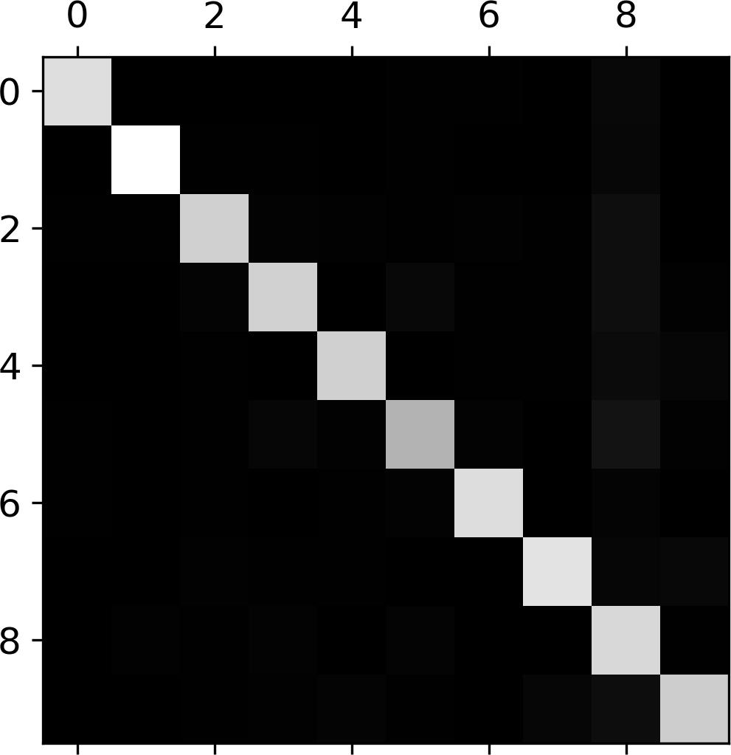

This confusion matrix looks fairly good, since most images are on the main diagonal, which means that they were classified correctly. The 5s look slightly darker than the other digits, which could mean that there are fewer images of 5s in the dataset or that the classifier does not perform as well on 5s as on other digits. In fact, you can verify that both are the case.

Let’s focus the plot on the errors. First, you need to divide each value in the confusion matrix by the number of images in the corresponding class, so you can compare error



**Error Analysis** **|** **105**

rates instead of absolute number of errors (which would make abundant classes look unfairly bad):

row_sums = conf_mx.sum(axis=1, keepdims=True) norm_conf_mx = conf_mx / row_sums

Now let’s fill the diagonal with zeros to keep only the errors, and let’s plot the result:

np.fill_diagonal(norm_conf_mx, 0) plt.matshow(norm_conf_mx, cmap=plt.cm.gray) plt.show()

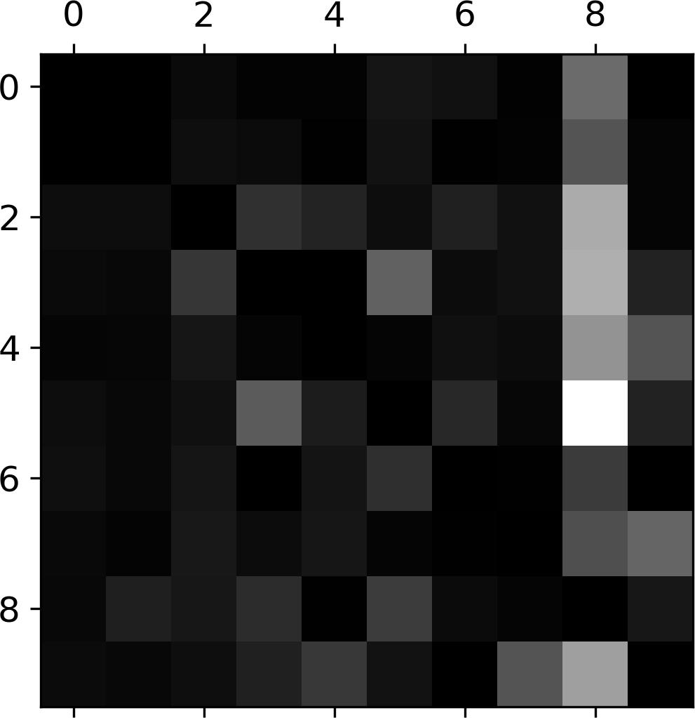

Now you can clearly see the kinds of errors the classifier makes. Remember that rows represent actual classes, while columns represent predicted classes. The column for class 8 is quite bright, which tells you that many images get misclassified as 8s. How‐ ever, the row for class 8 is not that bad, telling you that actual 8s in general get prop‐ erly classified as 8s. As you can see, the confusion matrix is not necessarily symmetrical. You can also see that 3s and 5s often get confused (in both directions).

Analyzing the confusion matrix can often give you insights on ways to improve your classifier. Looking at this plot, it seems that your efforts should be spent on reducing the false 8s. For example, you could try to gather more training data for digits that look like 8s (but are not) so the classifier can learn to distinguish them from real 8s. Or you could engineer new features that would help the classifier—for example, writ‐ ing an algorithm to count the number of closed loops (e.g., 8 has two, 6 has one, 5 has none). Or you could preprocess the images (e.g., using Scikit-Image, Pillow, or OpenCV) to make some patterns stand out more, such as closed loops.

Analyzing individual errors can also be a good way to gain insights on what your classifier is doing and why it is failing, but it is more difficult and time-consuming.



**106** **|** **Chapter 3: Classi€cation**

For example, let’s plot examples of 3s and 5s (the plot_digits() function just uses Matplotlib’s imshow() function; see this chapter’s Jupyter notebook for details):

cl_a, cl_b = 3, 5

X_aa = X_train[(y_train == cl_a) & (y_train_pred == cl_a)] X_ab = X_train[(y_train == cl_a) & (y_train_pred == cl_b)] X_ba = X_train[(y_train == cl_b) & (y_train_pred == cl_a)] X_bb = X_train[(y_train == cl_b) & (y_train_pred == cl_b)]

plt.figure(figsize=(8,8))

plt.subplot(221); plot_digits(X_aa[:25], images_per_row=5) plt.subplot(222); plot_digits(X_ab[:25], images_per_row=5) plt.subplot(223); plot_digits(X_ba[:25], images_per_row=5) plt.subplot(224); plot_digits(X_bb[:25], images_per_row=5) plt.show()

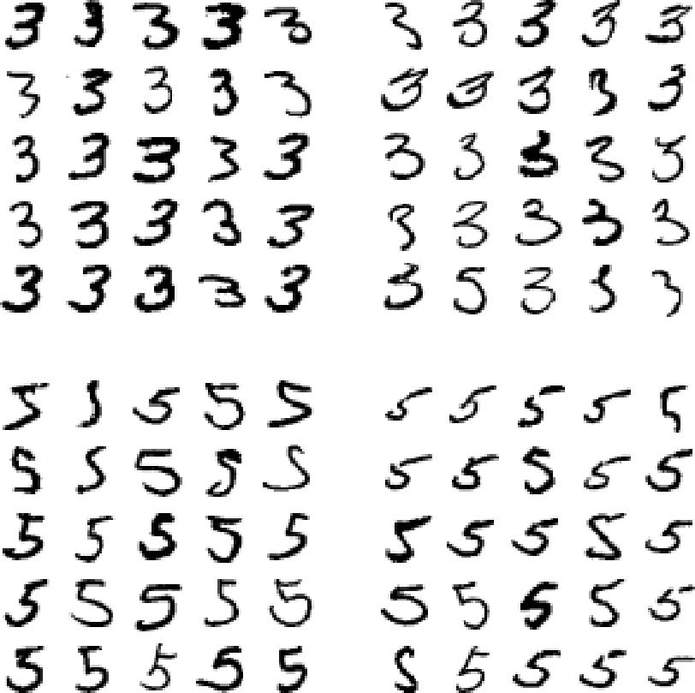

The two 5×5 blocks on the left show digits classified as 3s, and the two 5×5 blocks on the right show images classified as 5s. Some of the digits that the classifier gets wrong (i.e., in the bottom-left and top-right blocks) are so badly written that even a human would have trouble classifying them (e.g., the 5 on the 1st row and 2nd column truly looks like a badly written 3). However, most misclassified images seem like obvious errors to us, and it’s hard to understand why the classifier made the mistakes it did.3 The reason is that we used a simple SGDClassifier, which is a linear model. All it does is assign a weight per class to each pixel, and when it sees a new image it just sums up the weighted pixel intensities to get a score for each class. So since 3s and 5s differ only by a few pixels, this model will easily confuse them.



1. But remember that our brain is a fantastic pattern recognition system, and our visual system does a lot of complex preprocessing before any information reaches our consciousness, so the fact that it feels simple does not mean that it is.



**Error Analysis** **|** **107**

The main difference between 3s and 5s is the position of the small line that joins the top line to the bottom arc. If you draw a 3 with the junction slightly shifted to the left, the classifier might classify it as a 5, and vice versa. In other words, this classifier is quite sensitive to image shifting and rotation. So one way to reduce the 3/5 confusion would be to preprocess the images to ensure that they are well centered and not too rotated. This will probably help reduce other errors as well.

**Multilabel Classi€cation**

Until now each instance has always been assigned to just one class. In some cases you may want your classifier to output multiple classes for each instance. For example, consider a face-recognition classifier: what should it do if it recognizes several people on the same picture? Of course it should attach one tag per person it recognizes. Say the classifier has been trained to recognize three faces, Alice, Bob, and Charlie; then when it is shown a picture of Alice and Charlie, it should output [1, 0, 1] (meaning “Alice yes, Bob no, Charlie yes”). Such a classification system that outputs multiple binary tags is called a *multilabel classification* system.

We won’t go into face recognition just yet, but let’s look at a simpler example, just for illustration purposes:

**from sklearn.neighbors import** KNeighborsClassifier

y_train_large = (y_train >= 7) y_train_odd = (y_train % 2 == 1)

y_multilabel = np.c_[y_train_large, y_train_odd]

knn_clf = KNeighborsClassifier() knn_clf.fit(X_train, y_multilabel)

This code creates a y_multilabel array containing two target labels for each digit image: the first indicates whether or not the digit is large (7, 8, or 9) and the second indicates whether or not it is odd. The next lines create a KNeighborsClassifier instance (which supports multilabel classification, but not all classifiers do) and we train it using the multiple targets array. Now you can make a prediction, and notice that it outputs two labels:

**>>>** knn_clf.predict([some_digit])array([[False, True]])

And it gets it right! The digit 5 is indeed not large (False) and odd (True).

There are many ways to evaluate a multilabel classifier, and selecting the right metric really depends on your project. For example, one approach is to measure the F1 score for each individual label (or any other binary classifier metric discussed earlier), then simply compute the average score. This code computes the average F1 score across all labels:



**108** **|** **Chapter 3: Classi€cation**

* y_train_knn_pred = cross_val_predict(knn_clf, X_train, y_multilabel, cv=3)
* f1_score(y_multilabel, y_train_knn_pred, average="macro") 0.976410265560605

This assumes that all labels are equally important, which may not be the case. In par‐ ticular, if you have many more pictures of Alice than of Bob or Charlie, you may want to give more weight to the classifier’s score on pictures of Alice. One simple option is to give each label a weight equal to its *support* (i.e., the number of instances with that target label). To do this, simply set average="weighted" in the preceding code.4

**Multioutput Classi€cation**

The last type of classification task we are going to discuss here is called *multioutput-multiclass classification* (or simply *multioutput classification*). It is simply a generaliza‐tion of multilabel classification where each label can be multiclass (i.e., it can have more than two possible values).

To illustrate this, let’s build a system that removes noise from images. It will take as input a noisy digit image, and it will (hopefully) output a clean digit image, repre‐ sented as an array of pixel intensities, just like the MNIST images. Notice that the classifier’s output is multilabel (one label per pixel) and each label can have multiple values (pixel intensity ranges from 0 to 255). It is thus an example of a multioutput classification system.

The line between classification and regression is sometimes blurry, such as in this example. Arguably, predicting pixel intensity is more akin to regression than to classification. Moreover, multioutput systems are not limited to classification tasks; you could even have a system that outputs multiple labels per instance, including both class labels and value labels.



Let’s start by creating the training and test sets by taking the MNIST images and adding noise to their pixel intensities using NumPy’s randint() function. The target images will be the original images:

noise = np.random.randint(0, 100, (len(X_train), 784)) X_train_mod = X_train + noise

noise = np.random.randint(0, 100, (len(X_test), 784)) X_test_mod = X_test + noise

y_train_mod = X_train y_test_mod = X_test



1. Scikit-Learn offers a few other averaging options and multilabel classifier metrics; see the documentation for more details.



**Multioutput Classi€cation** **|** **109**

Let’s take a peek at an image from the test set (yes, we’re snooping on the test data, so you should be frowning right now):

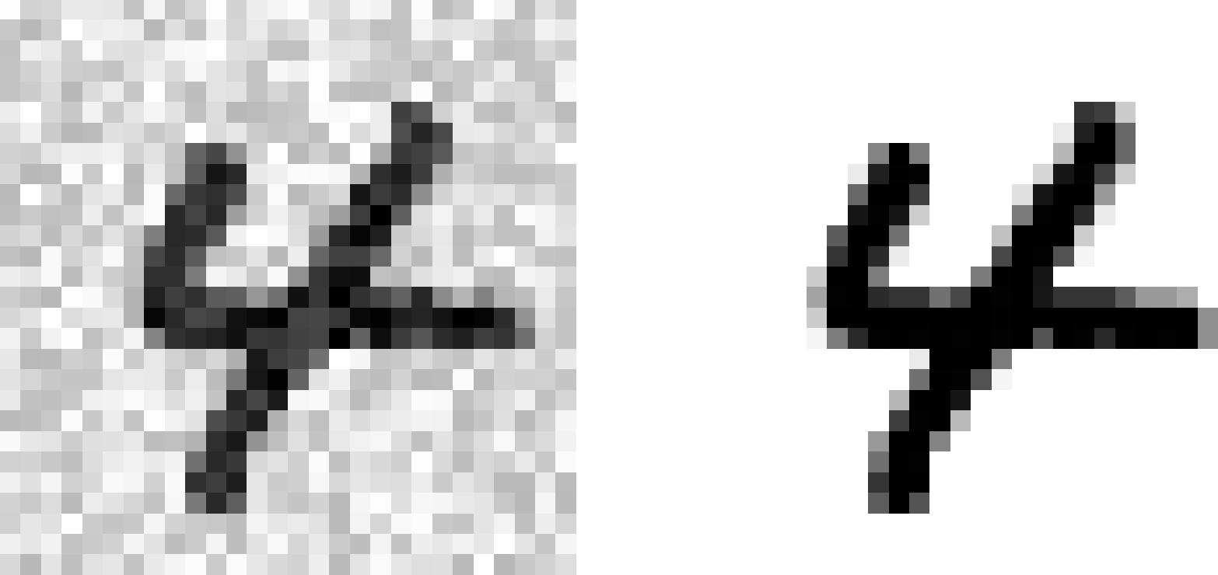

On the left is the noisy input image, and on the right is the clean target image. Now let’s train the classifier and make it clean this image:

knn_clf.fit(X_train_mod, y_train_mod)

clean_digit = knn_clf.predict([X_test_mod[some_index]]) plot_digit(clean_digit)



Looks close enough to the target! This concludes our tour of classification. Hopefully you should now know how to select good metrics for classification tasks, pick the appropriate precision/recall tradeoff, compare classifiers, and more generally build good classification systems for a variety of tasks.

**Exercises**

1. Try to build a classifier for the MNIST dataset that achieves over 97% accuracy on the test set. Hint: the KNeighborsClassifier works quite well for this task; you just need to find good hyperparameter values (try a grid search on the weights and n_neighbors hyperparameters).
2. Write a function that can shift an MNIST image in any direction (left, right, up, or down) by one pixel.5 Then, for each image in the training set, create four shif‐



1. You can use the shift() function from the scipy.ndimage.interpolation module. For example, shift(image, [2, 1], cval=0) shifts the image 2 pixels down and 1 pixel to the right.



**110** **|** **Chapter 3: Classi€cation**

ted copies (one per direction) and add them to the training set. Finally, train your best model on this expanded training set and measure its accuracy on the test set. You should observe that your model performs even better now! This technique of artificially growing the training set is called *data augmentation* or *training set* *expansion*.

1. Tackle the *Titanic* dataset. A great place to start is on [Kaggle](https://www.kaggle.com/c/titanic).
2. Build a spam classifier (a more challenging exercise):
   * Download examples of spam and ham from [Apache SpamAssassin’s public](https://spamassassin.apache.org/old/publiccorpus/) [datasets](https://spamassassin.apache.org/old/publiccorpus/).
   * Unzip the datasets and familiarize yourself with the data format.
   * Split the datasets into a training set and a test set.
   * Write a data preparation pipeline to convert each email into a feature vector. Your preparation pipeline should transform an email into a (sparse) vector indicating the presence or absence of each possible word. For example, if all emails only ever contain four words, “Hello,” “how,” “are,” “you,” then the email “Hello you Hello Hello you” would be converted into a vector [1, 0, 0, 1] (meaning [“Hello” is present, “how” is absent, “are” is absent, “you” is present]), or [3, 0, 0, 2] if you prefer to count the number of occurrences of each word.
   * You may want to add hyperparameters to your preparation pipeline to control whether or not to strip off email headers, convert each email to lowercase, remove punctuation, replace all URLs with “URL,” replace all numbers with “NUMBER,” or even perform *stemming* (i.e., trim off word endings; there are Python libraries available to do this).
   * Then try out several classifiers and see if you can build a great spam classifier, with both high recall and high precision.

Solutions to these exercises are available in the online Jupyter notebooks at [*https://*](https://github.com/ageron/handson-ml2) [*github.com/ageron/handson-ml2*](https://github.com/ageron/handson-ml2).



**Exercises** **|** **111**